Date: 26.8.2014

**Report on failure of Granulator coupling**

On 24.8.2014 Sunday at @2.30 pm, Granulator of Train-C was reported to have failure of the torque tube gear coupling between Gearbox Output shaft and the pinion shaft. This coupling is a Gear Type coupling with spacer. On inspection of the coupling, it was observed that teeth of the coupling were badly damaged. This was a coupling between gearbox output shaft and pinion operating at 98 rpm.

Since the new coupling available in spare is with pilot bore, immediate action was taken by maint. Deptt. to machine the bore in Central Workshop and prepare the new coupling for installation. In the meantime, to avoid production loss, it was decided to weld the coupling so as to run the machine temporarily to avoid production loss. On completion of welding, the machine was handed over to production on 24.8.2014 @6.30 pm.

Again on 25.8.2014 @ 7.45 pm, the granulator torque tube gear coupling got detached from the welding and resulted in Granulator shutdown. Again the repair was done by welding to avoid production loss and granulator was handed over at 12.30 midnight.

In the meantime, new coupling with finished bore and keyway is made ready and kept available for replacement. The plant has been stopped in a planned way at @11.00 am for replacement of the coupling and the work is under progress for replacement of new coupling.

Vibration level of the Granulator Train C was last measured before failure on 19.8.2014. Highest vibration level was 15.5 mm/sec on gearbox high speed shaft in Horizontal direction and max. 191 Micron on pinion shaft bearing. It was kept under observation. The report is attached below:

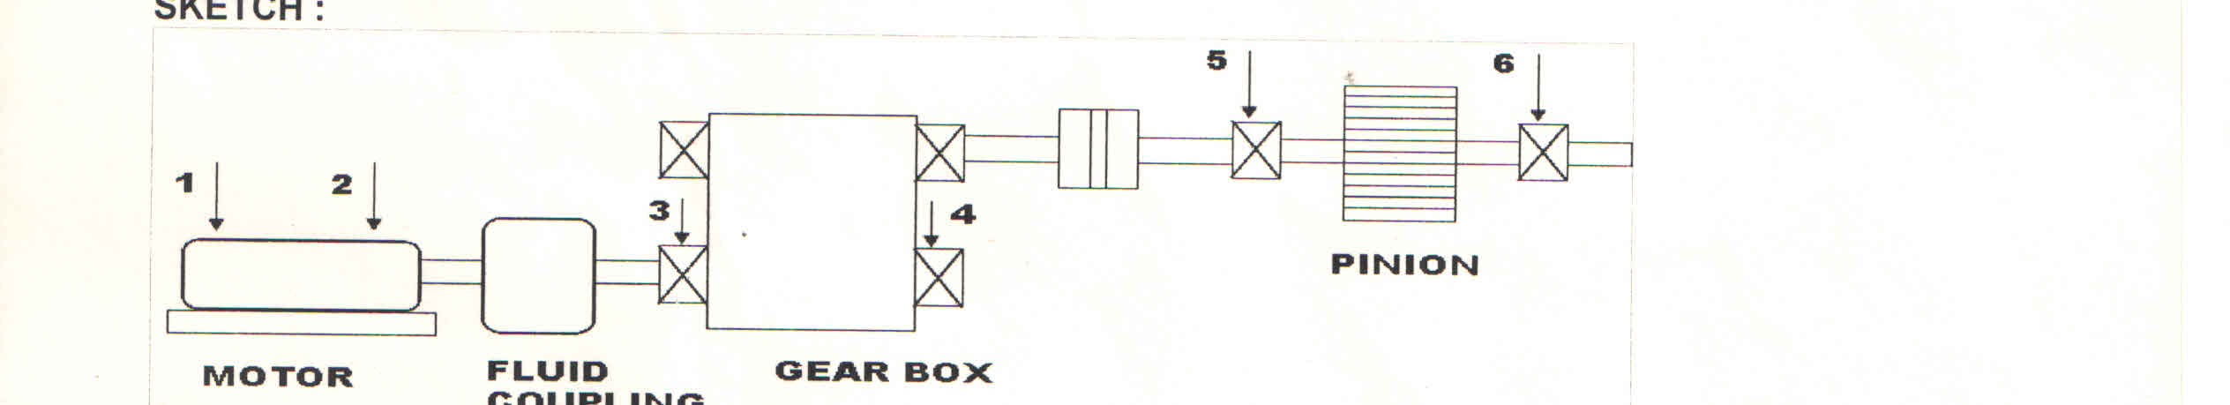

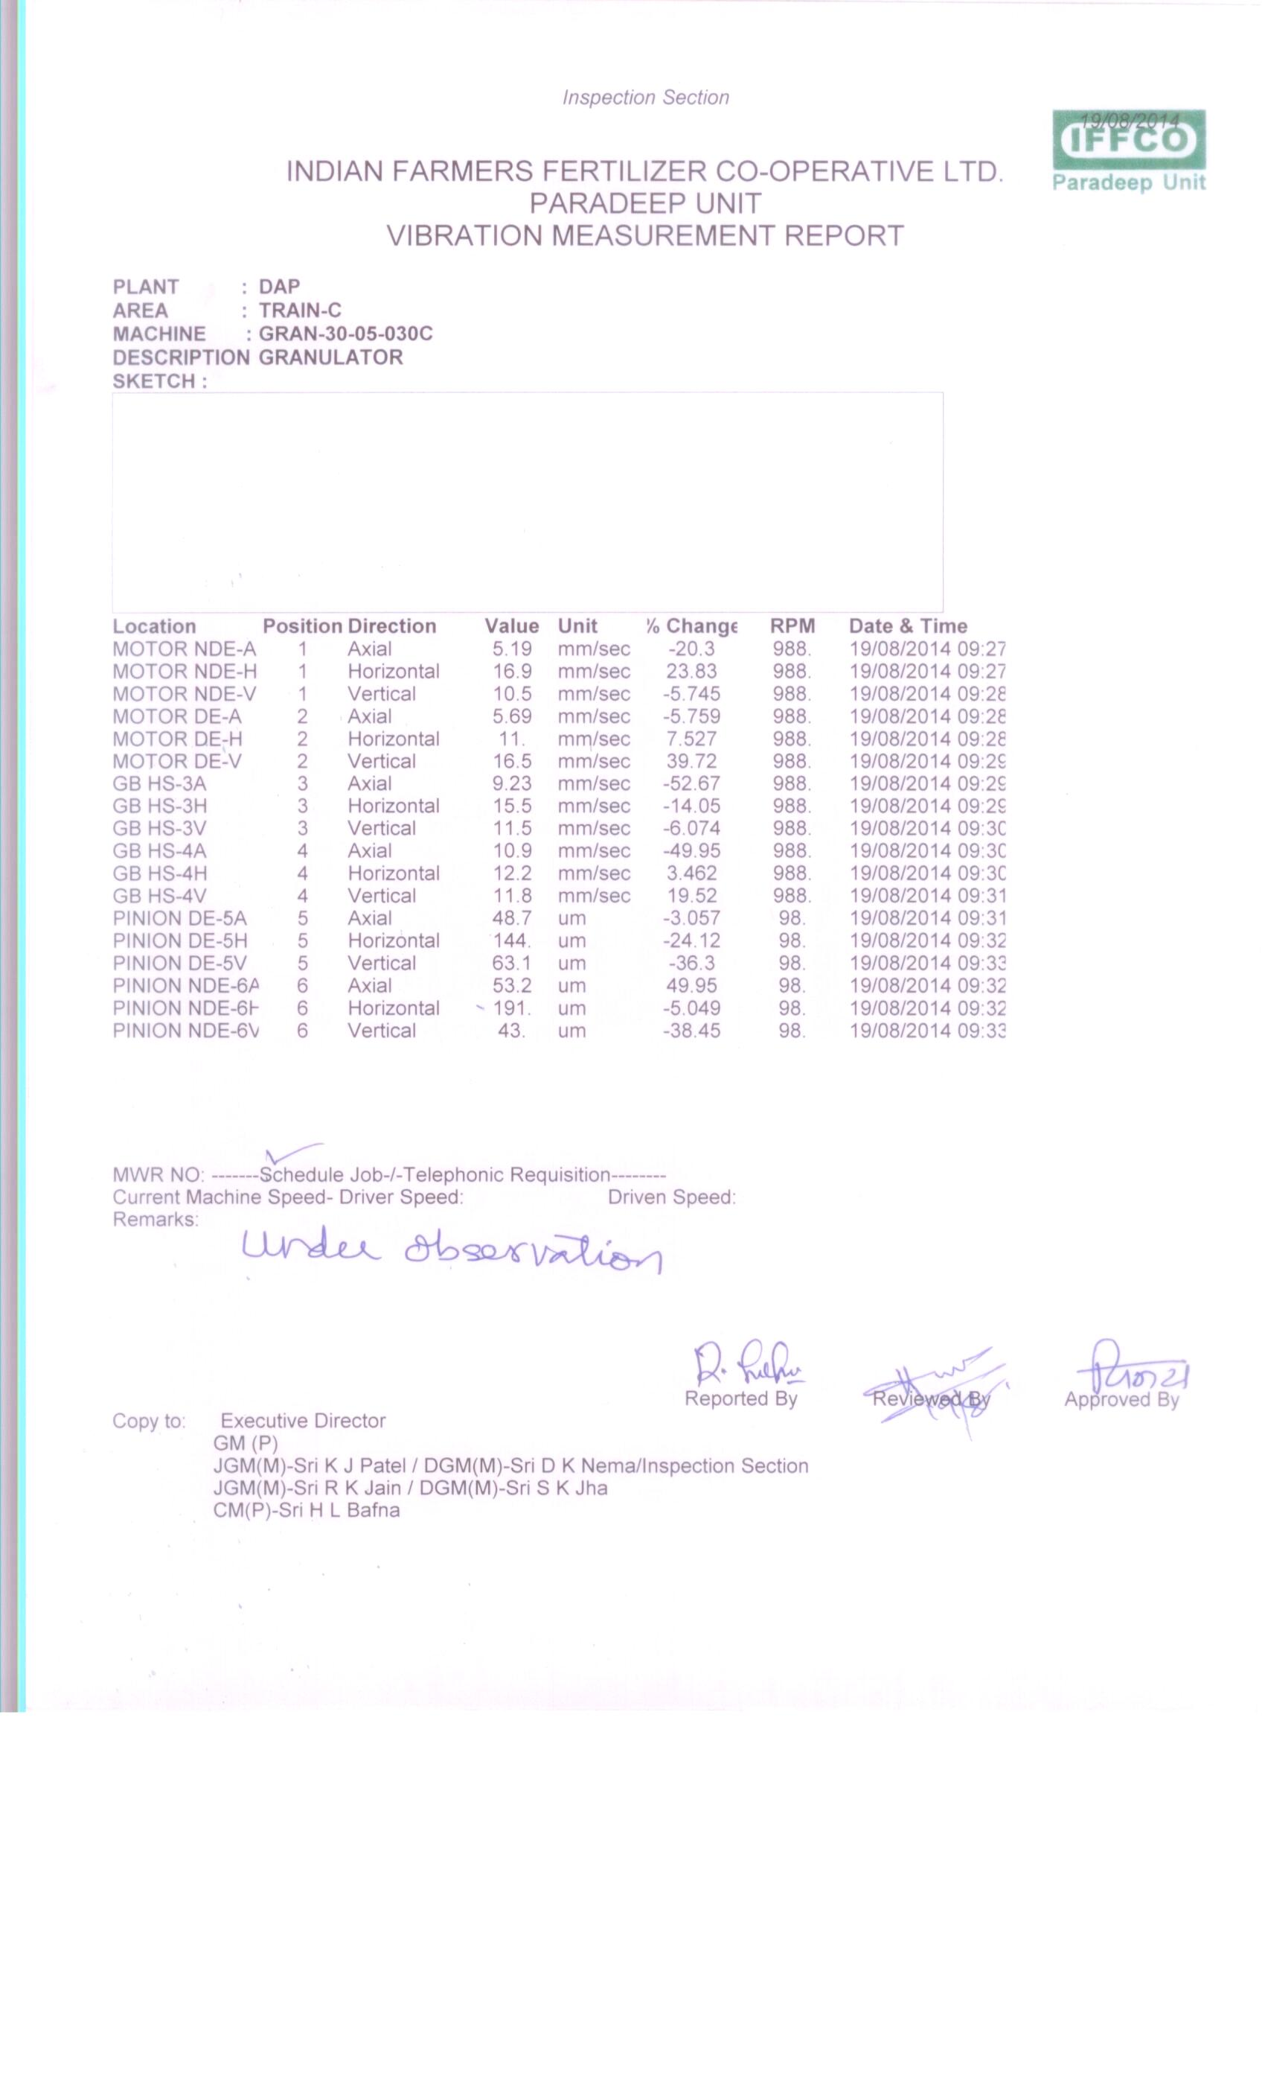

Highest vibration levels on gear box high speed shaft was 14.9 mm/sec in axial direction and 208 Micron on pinion shaft bearing. The vibration report is given below.

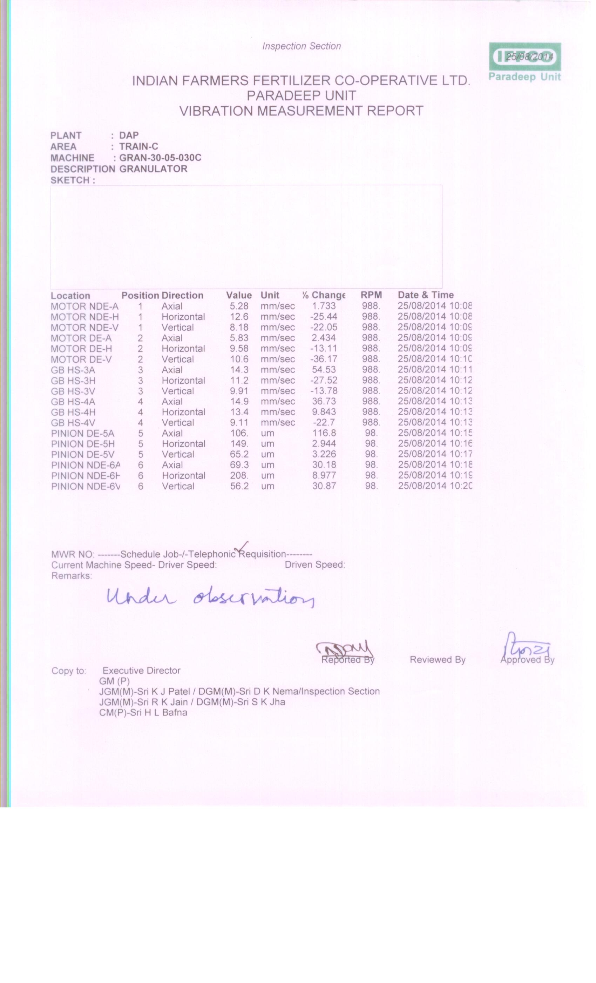

CONCLUSION:

From the vibration reports, it is evident that the vibration levels about 6 days before the failure were nearly fair and damage took place suddenly. This is predicted to be due to sudden and heavy shock load on the drives caused by solid lump formation inside the granulator. This is confirmed from the current trend taken for 24.8.2014 where at the time of the failure, the current suddenly shooted upto 41.88 Amps as against normal ampere level of 32 to 34 Amps. The trend chart is shown below:

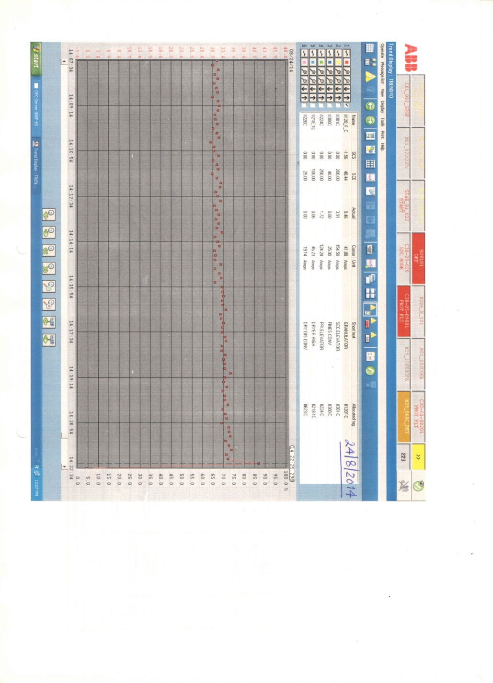

Second failure was due to weakening of the weld joint which got detached under normal load. The trend chart is shown below for reference.

